**Node Advance 1**

In asynchronous-->we don't wait for something to finish , rather we continue doing our work while its happening.

in synchronous,we wait for it to get complete.

we can request server for data but till it fetches the data ,we don't want to wait rather we do continue running our code (doing something else).

callback were used for this

after ES6 is introduced,promises are now used for it.

ES7-->dealing with promises but in different way-->deal with response in a way that it looks synchronous.

we don't use dot in async await as we used to do in promises

Callback:

httpModule.js

http module is basically used to create networking application

we can ceate web server and listen to http request on a given port

some classes of http module->http.agent,http.clientRequest

each class has its method,prperties and events

server is an event emittor

on,addlistener,emit-->methods of server

everytime there is new connection,new request,we hit server-->server raises an event

we can use on method to handle that event

where will we use promises?

1)when using fetch Api or Axios or mongoose library or

Promise in js

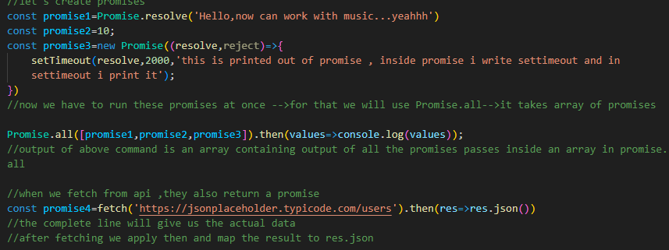

Async await

Async await -->it is a way to handle responses

-->in this function is labelled as async

-->awaits wait for an action to complete

